**AGENTES AUTÓNOMOS**

### 6.1 Forces from Within

Características de los agentes autónomos

Tienen habilidades limitadas para percibir el ambiente

Las limitaciones dependen de la situación y a menudo son útiles para agregar realismo a simulaciones de la naturaleza

Procesan la información del ambiente y calculan una acción a partir de dicha información

Esta acción puede ser una fuerza que produce trabajo si se trata de una visualización gráfica, esta es la labor principal de un desarrollador en proyectos con agentes autónomos.

No tienen un líder

Esta característica es la de menor importancia para el desarrollador, podría considerarse una consecuencia de las interacciones y dependencias que se crean en el sistema de tal manera que exhiben propiedades de sistemas complejos.

6.2 Vehicles and Steering

In the late 1980s, computer scientist Craig Reynolds

developed algorithmic steering behaviors for animated characters

These behaviors allowed individual elements to navigate their digital environments in a “lifelike” manner with strategies for fleeing, wandering, arriving, pursuing, evading, etc.

Used in the case of a single autonomous agent, these behaviors are fairly simple to understand and implement.

In addition, by building a system of multiple characters that steer themselves according to simple, locally based rules, surprising levels of complexity emerge.

The most famous example is Reynolds’s “boids” model for “flocking/swarming” behavior.

Reynolds describes the motion of idealized vehicles as a series of three layers

Action Selection

A vehicle has a goal (or goals) and can select an action (or a combination of actions) based on that goal.

Steering

Once an action has been selected, the vehicle must calculate its next move.

For us, the next move will be a force; more specifically, a steering force

Reynolds has developed a simple steering force formula that we’ll use throughout the examples in this chapter: steering $force = desired velocity - current velocity.$

Locomotion

For the most part, we’re going to ignore this third layer. In the case of fleeing zombies, the locomotion could be described as “left foot, right foot, left foot, right foot, as fast as you can.”

### 6.3 The Steering Force

Consider the following scenario. A vehicle moving with velocity desires to seek a target.

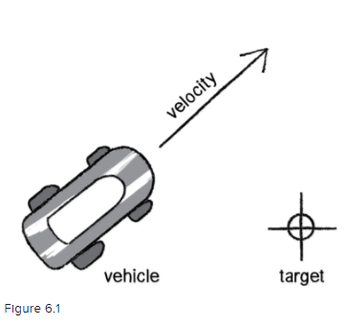

Its goal and subsequent action is to seek the target in Figure 6.1.

you might begin by making the target an attractor and apply a gravitational force that pulls the vehicle to the target.

This would be a perfectly reasonable solution, but conceptually it’s not what we’re looking for here.

We don’t want to simply calculate a force that pushes the vehicle towards its target

rather, we are asking the vehicle to make an intelligent decision to steer towards the target based on its perception of its state and environment (i.e. how fast and in what direction is it currently moving)

he vehicle should look at how it desires to move (a vector pointing to the target), compare that goal with how quickly it is currently moving (its velocity), and apply a force accordingly.